|  |  |  |
| --- | --- | --- |
|  |  |  |
|  | **Mandatory Grants 50 +**  **Frequently Asked Questions**  **April 2014** |  |
|  | http://www.fasset.org.za/images/nav_logo.gif  . |  |
|  |  |  |

# Contents

|  |  |
| --- | --- |
| Contents  1. Contents ii  FREQUENTLY ASKED QUESTIONS 1 | **1** |

# FREQUENTLY ASKED QUESTIONS

1. **Form 1 - Details of Employer** 
   1. Please ensure only the numeric value is added in the fields ie. R200 000.00 – only 200000 should be populated as the system will not recognize “R” or . or spaces in the fields
2. **Form 2 - Employment Summary 2014** 
   1. The template on the system needs to be used to populate the spreadsheet. The dropdown values are on the template which will assist the user to complete the data. There is also a spreadsheet on the template called dropdown please use this for guidance.
   2. If you are copying and pasting from the excel spreadsheet from the website please take note of the dropdown values on the create functionality and the dropdown value explanations on the excel importer spreadsheet. Screenshots attached.

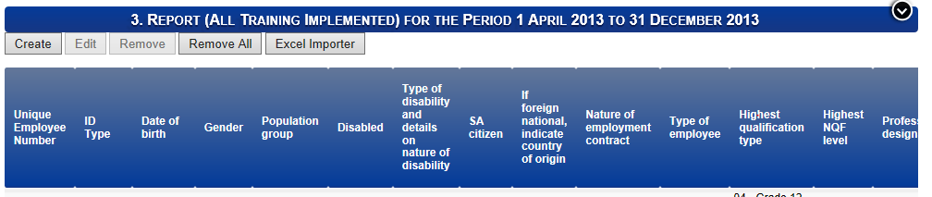

Click on Save and the required fields will be displayed

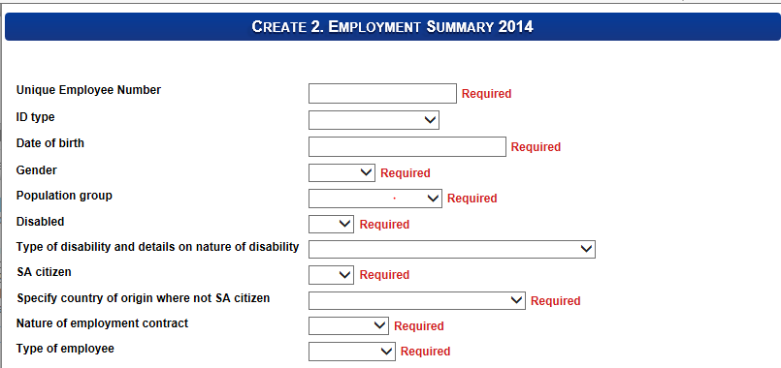

The excel importer can be used to upload bulk data – a template has been supplied to ensure the correct data format is used.

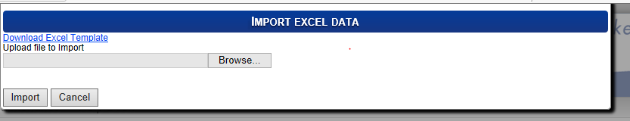

The following screen will be displayed

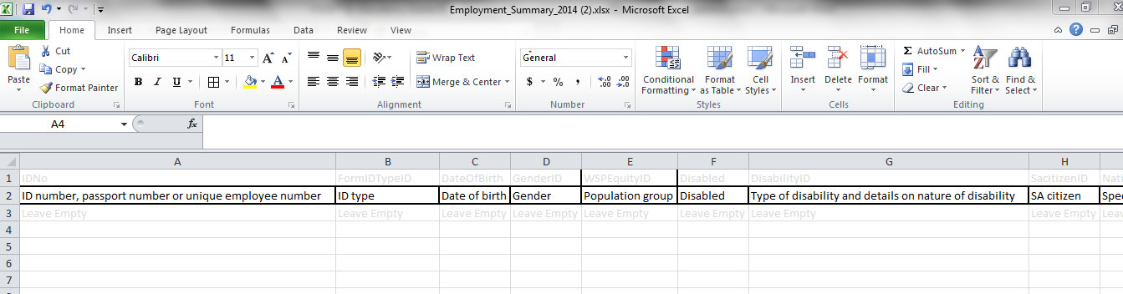

Each sheet has dropdown values which will guide the user on the format of the data to be uploaded for each field

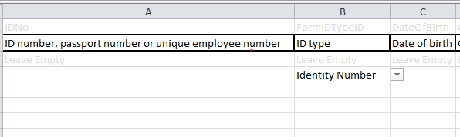

Spreadsheets will also include dropdown lists to guide on the values to be uploaded

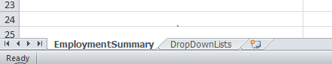

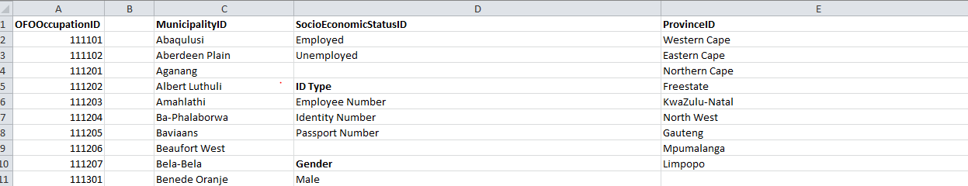

1. **Form 3 - Report (All Training Implemented) for the Period 1 April 2013 to 31 December 2013**
   1. The same principle and guidelines would apply as indicated above
   2. Only the sheet names on the excel importers will change
2. **Form 4 - Plan (All Training Planned except PIVOTAL programmes) by demographic status for the period 1 April 2014 to 31 December 2014**
   1. The same principle and guidelines would apply as indicated above
   2. The totals need to match – the age breakdown and equity / gender breakdown totals need to add up – the disability breakdown will be contained within the age and equity / gender breakdown and therefore need to total the same amount.
3. **Form 5 - Plan (All Training Planned for unemployed except PIVOTAL programmes) by educational level for the period 1 April 2014 to 31 December 2014**
   1. The same principle and guidelines would apply as indicated above
   2. Only the sheet names on the excel importers will change
4. **Form 6 - Plan (All Training Planned for employed except PIVOTAL programmes) by educational level for the period 1 April 2014 to 31 December 2014**
   1. The same principle and guidelines would apply as indicated above
   2. Only the sheet names on the excel importers will change
5. **Form 7 - Plan Adult Education and Training 2014**
   1. Please note this form is not compulsory
6. **Form 8 - PIVOTAL Training Plan (Planned PIVOTAL Programmes for unemployed and employed) for period 1 April 2014 to 31 December 2014**
   1. This form is not compulsory and the data can be submitted without the completion of this form.
   2. The totals need to match – the age breakdown and equity / gender breakdown totals need to add up – the disability breakdown will be contained within the age and equity / gender breakdown and therefore need to total the same amount.
7. **Form 9 - Verified PIVOTAL Training Plan (Planned PIVOTAL Programmes for unemployed and employed) for period 1 April 2014 to 31 December 2014**
   1. The same principle and guidelines would apply as indicated above
   2. Only the sheet names on the excel importers will change
8. **Form 10 - PIVOTAL Training Plan (PIVOTAL Programmes for unemployed) by educational level for period 1 April 2014 to 31 December 2014**
   1. The same principle and guidelines would apply as indicated above
   2. Only the sheet names on the excel importers will change
9. **Form 11 - PIVOTAL Training Plan (PIVOTAL Programmes for employed) by educational level for period 1 April 2013 to 31 March 2014**
   1. The same principle and guidelines would apply as indicated above
   2. Only the sheet names on the excel importers will change
10. **Form 12 - Scarce Skills 2014 and 2015**
    1. The Occupational Level (6 digit OFO code) is not compulsory on this sheet

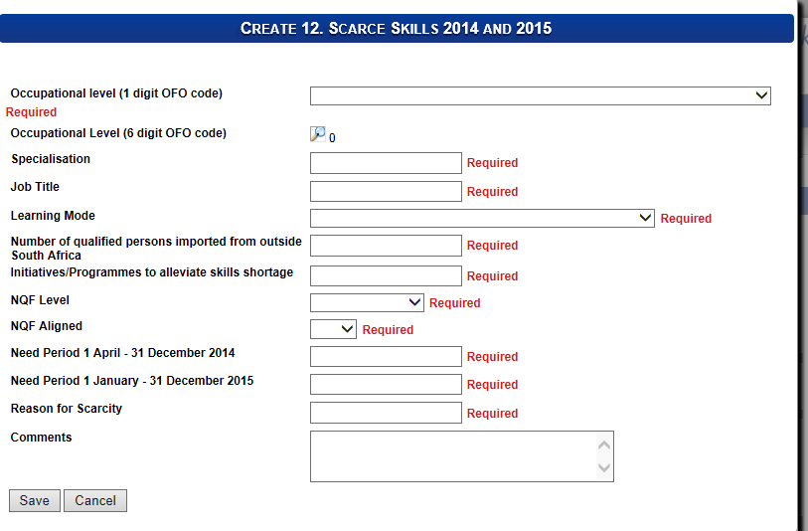

1. **Form 13 - Grant Awareness 2014**
   1. Tick box functionality is available on this sheet please tick the relevant box(s)

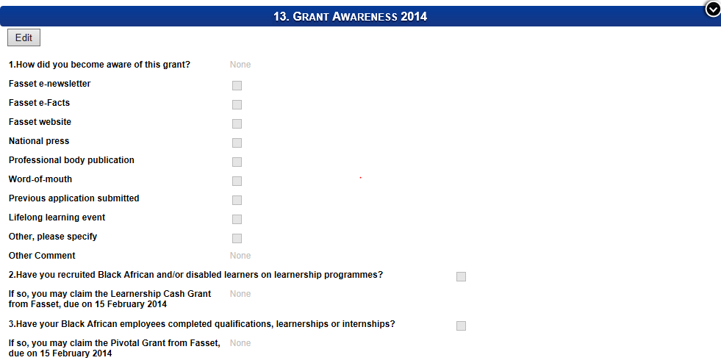

1. **Form 14 - Impact of Staff Training 2013/2014**
   1. The scale of 1 – 5 should be used to populate this sheet

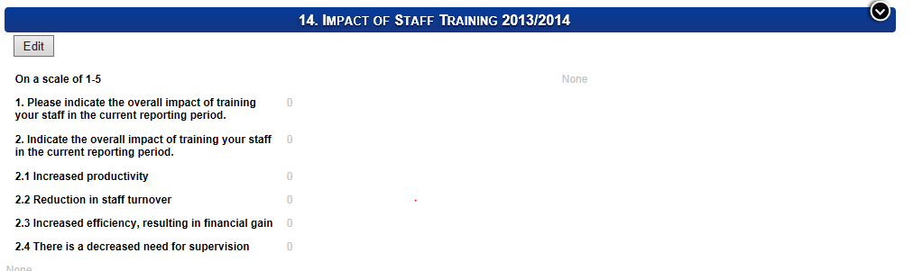

1. **Form 15 - General Comments**
   1. No questions have been received on this issue.